**1.** You download an Azure resource Manager template based on an existing Virtual

machine. The template will be used to deploy 100 virtual machines. You need to

modify the template to reference an administrative password. You must prevent the

password from being stored in plain text.

What should you create to store the password?

A. Azure Storage account and access policy

B. Azure Key vault and access policy

C. Azure AD identity protection and Azure policy

D. Recovery services vault and backup policy

**2.** You plan to deploy 3 Virtual Machines named VM1, VM2 and VM3. The virtual

machines will host a web app named App1. You need to ensure that at least 2

virtual machines are available if a single Azure data center becomes unavailable.

What should you deploy ?

A. Each virtual machine in a separate availability zone.

B. All three virtual machines in a single availability zone.

C. All Virtual machines in a single availability Set.

D. Each virtual machine in a separate availability Set.

**3.** Your company has virtual machines hosted in Microsoft Azure. The VMs are located

in a single Azure virtual network named VNet1. The company has users that work

remotely. The remote workers require access to the VMs on VNet1. You need to

provide access for the remote workers. What should you do?

A. Configure a Site-to-Site (S2S) VPN

B. Configure a Point-to-Site (P2S) VPN

C. Configure a Multi Site VPN

D. Configure a VNet-to-VNet VPN

**4.** You have an Azure virtual machine VM1 that runs Windows Server 2022. You save

VM1 as a template named Template1 to the Azure Resource Manager library. You

plan to deploy a virtual machine named VM2 from Template1.

Which of the following you need to configure during the deployment of VM2?

(Choose two)

A. Resource Group

B. Operating System

C. Virtual Machine Size

D. Administrator Username

**5.** Your Company wants to share the JSON files stored in a container inside a storage

account. What is the correct url for the file called 'employee_data.json'?

Storage Account :'monthlyreports'

Container: 'may2023'

File: 'employee_data.json'

A. https://employee_data.json

B. https://monthlyreports.blob.core.windows.net/may2023/employee_data.json

C. https://monthlyreports/may2023/employeedata.json

D. https://monthlyreports.blob.core.windows.net/employee_data.json

**6.** A Company needs to connect their on-premise data centers to Azure. They have

huge workloads that need to regularly transfer between on premise data centers

and Azure. The company wants to avoid sending data over the public internet for

security reasons. Which of the following options should the company opt to

establish this connection?

A. Create a Point-to-Site (P2S) Connection

B. Create a Site-to-Site (S2S) Connection

C. Create an ExpressRoute Connection

D. Create a VNet-to-VNet Connection

**7.** Your company wants to move an entire solution to Azure. Due to security

constraints company wants to restrict creation of all resources in a particular region.

Which Azure service can be used to achieve this requirement?

A. Azure Policy

B. Azure Monitor

C. Azure Availability Zone

D. Azure Web Apps

**8.** A company has a Azure subscription which contains resource group named RG1

which is set to Australia East location. RG1 is used to host temporary resources and

contains resources shown below?

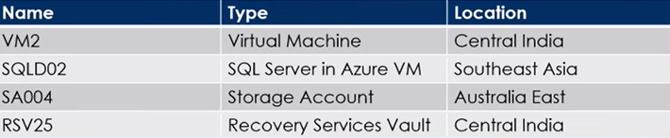

SQLD02 is backed up to RSV25. When a user tries to delete RG1 from Azure Portal,

the deletion fails. What is the first needs to take to ensure a successful deletion?

A. Delete Storage Account SA004

B. Restart VM2

C. Stop backup of SQLD02

D. Stop VM2

**9.** A Company needs to identify idle and underutilized Azure Virtual machines which

can be changed to a less costly service tier. What should the company use?

A. File Storage

B. Azure Advisor

C. Azure Monitor

D. Customer Insights

**10.** You have an Azure subscription named subscription1. You have 5TB of data that

you need to transfer to subscription1. You plan to use Azure Import/Export job.

What can you use as the destination of the imported data?

A. Azure File Storage

B. Azure Data Factory

C. Azure Cosmos DB

D. Azure SQL Database

**11.** Your company has a Microsoft SQL Server Always On availability group

configured on their Azure virtual machines (VMs). You need to configure an

Azure internal load balancer as a listener for the availability group.

Solution: You create an HTTP health probe on port 1433.

Does the solution meet the goal?

A. Yes

B. No

**12.** You have an Azure subscription named subscription1. You have 5TB of data that

you need to transfer to subscription1. You plan to use Azure Import/Export job.

What can you use as the destination of the imported data?

A. Azure Cosmos DB

B. Azure Data Factory

C. Azure Blob storage

D. Azure SQL Database

**13.** Your company has a Microsoft SQL Server Always On availability group

configured on their Azure virtual machines (VMs). You need to configure an

Azure internal load balancer as a listener for the availability group.

Solution: You create an TCP health probe on port 1433.

Does the solution meet the goal?

A. Yes

B. No

**14.** You have an Azure subscription that contains an Azure Storage account and You

plan to copy an on-premises virtual machine image to a container named vmimages. Which command should you run to create the container for the

planned image ?

azcopy 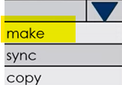

'https://devopshubstorage.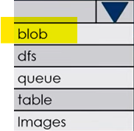. core windows.net/vmimages'

**15.** A company has a requirement to deploy Windows VM in its subscription. Which

CLI command should the administrator run in order to create the Virtual Machine?

A. New-AzVM

B. Create-AzVM

C. New-AzureRmVM

D. az vm create

**16.** Your company has an Azure Active Directory (Azure AD) subscription. You need to deploy five virtual machines (VMs) to your company's virtual network subnet. The VMs will each have both a public and private IP address. Inbound and outbound security rules for all of these virtual machines must be identical. Which of the following is the least amount of network interfaces needed for this configuration?

A. 5

B. 10

C. 20

D. 40

**17.** Your company has a general-purpose v1 Azure Storage account named storage1

that uses locally-redundant storage (LRS). You are tasked with implementing a solution that ensures the data in the storage account is protected if a zone fails. The solution must minimize costs and administrative effort. What should you do first?

A. Configure Object replication rules

B. Create a new storage account

C. Modify the replication settings of the storage account

D. Upgrade the account to general purpose V2

**18.** You have an Azure subscription named Subscription1 that contains the resources

shown in the following table.

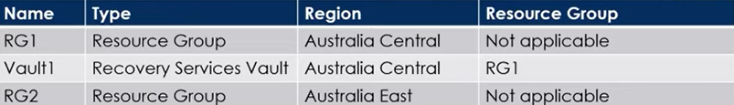

You create virtual machines in Subscription1 as shown in the following table.

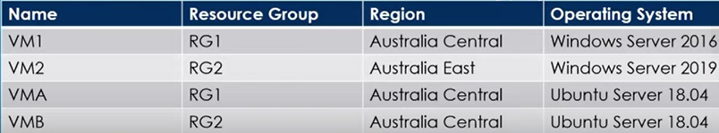

You plan to use Vaulti for the backup of as many virtual machines as possible. Which virtual machines can be backed up to Vault1?

A. VM2 only

B. VM1 and VMA only

C. VM1, VMA and VMB only

D. VM2 and VMB only

**19.** You have an Azure Active Directory tenant named contosocloud.onmicrosoft.com. Your company has a public DNS zone for contoso.com. You add contoso.com as a custom domain name to Azure AD. You need to ensure that Azure can verify the domain name. Which type of DNS record should you create?

A. MX

B. NSEC

C. RRSIG

D. PTR

**20.** You have an Azure subscription that contains an Azure Active Directory tenant

named contoso.com and an Azure Kubernetes Service (AKS) cluster named AKS1. An administrator reports that she is unable to grant access to AKS1 to the users in contoso.com. You need to ensure that access to AKS1 can be granted to the contoso.com users. What should you do first?

A. From contoso.com, create an OAuth 2.0 authorization endpoint.

B. From contoso.com, modify the Organization relationships settings.

C. Recreate AKS1

D. From AKS1, create a namespace.

**21.** Your organization's system administrator has deployed two standalone Azure

Virtual Machines for a new web service. You now want to add these virtual machines to fault domains in an availability set. When you attempt to do this in the portal, you receive an error message preventing you from completing the task. What is the reason for this?

A. The availability set has to be paused or stopped before Standalone VMs can be

added.

B. VMs Operating system is not compatible with fault domains

C. You didn't check the required "Standalone" parameter in Azure Portal

D. You can't add running Standalone VMs to availability sets.

**22.** Which Azure tool is a cloud based command line service for copying and migrating data between Azure Storage accounts?

A. Import/Export Service

B. AzCopy

C. Azure Data Box

D. Azure Storage Explorer

**23.** You Suspect hackers and bots have been attacking your applications network.

What Azure network monitoring or analysis tool would best fit your needs?

A. Security Group View

B. Network Performance monitor

C. Connection monitor

D. Traffic Analysis

**24.** You have an Azure subscription that contains the following users in an Azure AD

tenant named contoso.onmicrosoft.com?

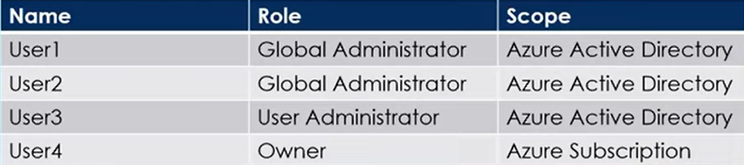

User1 creates a new Azure AD tenant named external contoso.onmicrosoft.com

You need to create new user accounts in external.contoso.onmicrosoft.com

Solution : You instruct User1 to create the user accounts.

Does the solution meet the goal?

A. Yes

B. No

**25.** Your company has a Microsoft Azure Subscription. The company has data centers in Los Angeles and New York, and you are configuring the two data centers as geo-clustered sites for site resiliency. You need to recommend an Azure storage redundancy option which fulfills the following data storage requirements.

* Data must be stored on multiple nodes.
* Data must be stored on nodes in separate geographic locations.
* Data can be read from the secondary location as well as from the Primary location.

Which of the following options should you recommend?

A. Read only geo redundant Storage

B. Zone redundant Storage

C. Locally redundant Storage

D. Geo redundant Storage

**26.** Your company has three virtual machines that are included in an availability set. You try to resize one of the VMs which returns an allocation failure message.

Which of the following actions should you take to resize the VM?

A. You should stop the VM

B. You should stop the other two VMs

C. You should stop all three VMs

D. You should remove the necessary VM from the availability set.

**27.** You create an Azure storage account named contosostorage. You plan to create a file share named data. Users need to map a drive from their home computers that run windows 11 to the data file share. Which outbound port should you open between the home computer and data file share?

A. 80

B. 443

C. 445

D. 3389

**28.** When using Azure resource manager (ARM) templates, what feature enables you to control resource properties during deployment in your organization?

A. Active Directory

B. Azure Policy

C. API Management

D. Resource tags

**29.** You have an Azure Subscription that contains a resource group named RG1. You plan to use an ARM template named template1 to deploy resources and the solution must meet following requirements.

* Deploy new resources to RG1
* Remove all the existing resources from RG1 before deploying the new resources.

Select the appropriate options to complete the command.

New-AzResourceGroupDeployment -TemplateUri "https://contoso.com/template1"

-TemplateParameterFile params.json 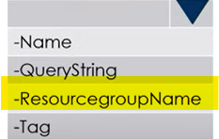 RG1-Mode 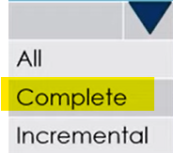

**30.** Your company has an Azure subscription. You need to deploy a number of Azure virtual machines (VMs) using Azure Resource Manager (ARM) templates. You have been informed that the VMs will be included in a single availability set. You are required to make sure that the ARM template you configure allows for as many VMs as possible to remain accessible in the event of fabric failure or maintenance. Which of the following is the value that you should configure for the platformUpdateDomainCount property?

A. 10

B. 20

C. 30

D. 40

**31.** Which Azure Storage service is designed for large-scale, offline data migration intended to help businesses migrate their data onto the Azure Cloud?

A. StorSimple

B. AzCopy

C. Azure Storage Explorer

D. Azure Data Box

**32.** You plan to deploy several Azure Virtual machines that will run Windows server 2022 in a virtual machine scale set by using ARM template. You need to ensure that NGINX is available on all the virtual machines after they are deployed. Whatshould you use?

A. A Microsoft Intune device configuration profile

B. Deployment Center in Azure App Service.

C. A Desired State Configuration (DSC) extension

D. The New-AzConfigurationAssignment cmdlet

**33.** You have an on-premises file server named Server1 that runs Windows Server 2016. You have an Azure subscription that contains an Azure file share. You deploy an Azure File Sync Storage Sync Service, and you create a sync group. You need to synchronize files from Server1 to Azure. Which four actions should you perform in sequence? To answer move the appropriate actions from the list of actions to the answer area and arrange in correct order.

Actions Answer Area

Install the Azure File Sync agent

on Server1.

Install the DFS replication server

role on Server1.

Create a sync group and a Cloud

endpoint.

Create a Recovery services vault.

Register Server1.

Add a Server endpoint.

**34.** You have an Azure subscription that contains the storage accounts shown in the

following table.

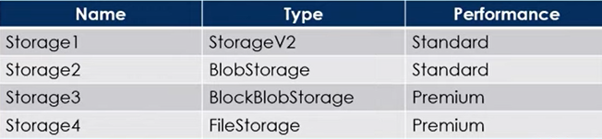

You plan to manage the data stored in the accounts by using lifecycle management

rules. To which storage accounts can you apply lifecycle management rules?

A. storage1 only

B. storage1 and storage2 only

C.storage3 and storage4 only

D. storage1, storage2 and storage3 only

E. storage1, storage2 , storage3 and storage4.

<https://learn.microsoft.com/en-us/azure/storage/blobs/lifecycle-management-overview>

**35.** Your company has a Microsoft SQL Server Always On availability group configured on their Azure virtual machines (VMs). You need to configure an Azure internal load balancer as a listener for the availability group.

**Solution:** You enable Floating IP.

Does the solution meet the goal?

A. Yes

B. No

<https://learn.microsoft.com/en-us/azure/azure-sql/virtual-machines/windows/availability-group-load-balancer-portal-configure?view=azuresql>

**36.** You plan to track resource usage and prevent the deletion of resources. To which resources can you apply locks and tags? To answer, select appropriate options in the answer area.

Locks: 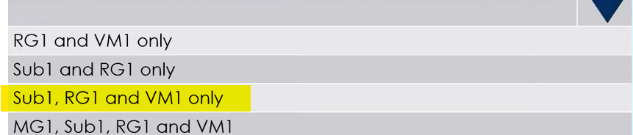

Tags: 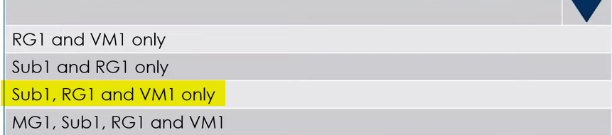

**37.** You have a computer named Computer1 that has a point-to-site VPN connection to an Azure virtual network named VNet1. The point-to-site connection uses a self-signed certificate. From Azure, you download and install the VPN client configuration package on a computer named Computer2. You need to ensure that you can establish a point-to-site VPN connection to VNet1 from Computer2.

**Solution:** You modify the Azure Active Directory (Azure AD) authentication policies.

Does the solution meet the goal?

A. Yes

B. No

**38.** You have an Azure subscription named Subscription1 that contains a virtual network named VNet1. VNet1 is in a resource group named RG1. Subscription1 has a user named User1. User1 has the following roles:

* Reader
* Security Admin
* Security Reader

You need to ensure that User1 can assign the Reader role for VNet1 to other users.

What should you do?

A. Assign User1 the Network Contributor role for VNet1.

B. Assign User1 the Owner role for VNet1.

C. Remove User1 from the Security Reader role for Subscription1. Assign User1 the

Contributor role for RG1.

D. Assign User1 the Contributor role for VNet1.

<https://learn.microsoft.com/en-us/azure/role-based-access-control/built-in-roles>

**39.** You have an Azure Active Directory (Azure AD) tenant named contoso.com. You have a CSV file that contains the names and email addresses of 500 external users. You need to create a guest user account in contoso.com for each of the 500 external users.

**Solution:** From Azure AD in the Azure portal, you use the Bulk create user operation.

Does this meet the goal?

A. Yes

B. No

**40.** You plan to automate the deployment of a virtual machine scale set that uses the Windows Server 2016 Datacenter image. You need to ensure that when the scale set virtual machines are provisioned, they have web server components installed.

Which two actions should you perform?

A. Create an automation account.

B. Upload a configuration script

C. Create an Azure policy

D. Modify the ExtensionProfile section of the Azure Resource Manager template

E. Create a new virtual machine scale set in the Azure portal

**41.** You have an Azure virtual machine named VM1 that runs Windows Server 2019. You need to create an alert in Azure when more than two error events are logged to the System event log on VM1 within an hour.

**Solution:** You create an event subscription on VM1. You create an alert in Azure Monitor and specify VM1 as the source.

Does this meet the goal?

A. Yes

B. No

<https://learn.microsoft.com/en-us/azure/azure-monitor/agents/agents-overview>

**42.** You have an Azure subscription named Subscription1 that contains an Azure Log Analytics workspace named Workspace1. You need to view the error events from a table named Event. Which query should you run in Workspace1?

A. search in (Event) * | where EventType eq "error"

B. select * from Event where EventType == "error"

C. Event | search "error"

D. Get-Event Event | where {$ _. EventType == "error"}

<https://learn.microsoft.com/en-us/azure/data-explorer/kusto/query/search-operator#search-predicate-syntax>

**43.** Your company has two on-premises servers named SRV01 and SRV02. Developers have created an application that runs on SRV01. The application calls a service on SRV02 by IP address. You plan to migrate the application on Azure virtual machines. You have configured two VMs on a single subnet in an Azure virtual network. You need to configure the two VMs with static internal IP addresses.

What should you do?

A. Modify the IP properties in Windows Network and Sharing Center.

B. Run the Set-AzureStaticVNetIP PowerShell cmdlet.

C. Modify the VM properties in the Azure Management Portal.

D. Run the New-AzureRMVMConfig PowerShell cmdlet.

E. Run the Set-AzureSubnet PowerShell cmdlet

**44.** You have an Azure subscription named Subscription1. You create an Azure Storage account named contosostorage, and then you create a file share named data. Which UNC path should you include in a script that references files from the data file share? To answer, drag the appropriate values to the correct targets. Each value may be used once, more than once or not at all?

|  |  |
| --- | --- |
| Values | Answer area |
| blob  contosostorage  file.core.windows.net  data  blob.core.windows.net | \\ . \  data  file.core.windows.net  contosostorage |

**45.** Your company has an Azure Active Directory (Azure AD) tenant that is configured for hybrid coexistence with the on-premises Active Directory domain. The on-premise virtual environment consists of virtual machines running on Windows Server 2012 R2 Hyper-V host servers. You have created some PowerShell scripts to automate the configuration of newly created VMs. You plan to create several new VMs and need a solution that ensures the scripts are run on the new VMs. Which of the following is the best solution?

A. Place the scripts in a new virtual hard disk (VHD).

B. Configure a Group Policy Object (GPO) to run the scripts as startup scripts.

C. Configure a SetupComplete.cmd batch file in the %windir%\setup\scripts directory.

D. Configure a Group Policy Object (GPO) to run the scripts as logon scripts.

**46.** You have an Azure Directory tenant named DevOpsHub and an Azure Subscription named Subscription1. DevOpsHub contains a group named Developers. Subscription1 contains a resource group named Dev. You need to provide the Developers group with the ability to create Azure logic apps in the Dev resource group.

**Solution:** On Subscription1, you assign the Logic App Operator role to the Developers group.

Does this meet the goal?

A. Yes

B. No

**47.** Your company has an Azure Active Directory (Azure AD) tenant that is configured for hybrid coexistence with the on-premises Active Directory domain. You plan to deploy several new virtual machines in Azure. The VMs will have the same operating system and custom software requirements. You configure a reference VM in the on-premise virtual environment. You then generalize the VM to create an image. You need to upload the image to Azure to ensure that it is available for selection when you create the new Azure VMs. Which PowerShell cmdlets should you use?

A. Add-AzlmageDataDisk

B. Add-Azlmage

C. Add-AzVhd

D. Add-AzVM

**48.** You have an Azure policy as shown in the following exhibit What is the effect of the policy?

A. You can create Azure SQL servers in contosoRG1 only

B. You are prevented from creating azure SQL Servers in ContosoRG1

only.

C. You can create Azure SQL servers in any resource group within Subscription.

D. You are prevented from creating Azure SQL servers anywhere in Subscription 1.

**49.** You have an Azure AD tenant named devopshub.com that contains the groups

shown in the table on the left. devopshub.com contains the users shown in the table on the right.

|  |  |
| --- | --- |
|  |  |

You assign the Azure Active Directory Premium Plan 2 license to Group1 and User4. Which users are assigned the Azure Active Directory Premium Plan 2 license?

1. User1, User2 and User4 only.
2. User 4 only.
3. User1 and User4 only.
4. User1, User2, User3 and User4.

**49.** Your company has an azure subscription that includes a storage account, a resource group, a blob container, and a file share. A colleague named Jim Taylor makes use of a solitary Azure Resource Manager (ARM) template to deploy a virtual machine and an additional Azure Storage account. You want to review the ARM template that was used by Jim Taylor.

**Solution:** You access the Resource Group blade.

Does the solution meet the goal?

A. Yes

B. No

**50.** You have an Azure subscription named Subscription1 and an on-premises deployment of Microsoft System Center Service Manager. Subscription1 contains virtual machine named VM1. You need to ensure that an alert is set in Service Manager when the amount of available memory on VM1 is below 10 percent.

What should you do first?

A. Deploy a function app.

B. Create an automation runbook.

C. Create a notification.

D. Deploy the IT Service Management Connector (ITSM)

**51.** You have three offices and an Azure subscription that contains an Azure Active Directory (Azure AD) tenant. You need to grant user management permissions to a local administrator in each office. What should you use?

A. Access packages in Azure AD entitlement management

B. Azure roles

C. Administrative units

D. Azure AD roles

**52.** You have an Azure subscription named Subscription1. Subscription1 contains the resource groups in the following table.

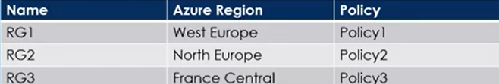

RG1 has a web app named WebApp1. WebApp1 is located in West Europe.

You move WebApp1 to RG2. What is the effect of the move?

A. The App Service plan for WebApp1 moves to North Europe. Policy1 applies to WebApp1.

B. The App Service plan for WebApp1 remains in West Europe. Policy2 applies to WebApp1.

C. The App Service plan for WebApp1 moves to North Europe. Policy2 applies to WebApp1.

D. The App Service plan for WebApp1 remains in West Europe. Policy1 applies to WebApp1.

**53.** You have an Azure virtual machine named VM1 that runs Windows Server 2019. The VM was deployed using default drive settings. You sign in to VM1 as a user named User1 and perform the following actions:

* Create files on drive C.
* Create files on drive D.
* Modify the screen saver timeout.
* Change the desktop background.

You plan to redeploy VM1. Which changes will be lost after you redeploy VM1?

A. The new files on drive C

B. The new desktop background

C. The modified screen saver timeout

D. The new files on drive D

**54.** You deploy an Azure Kubernetes Service (AKS) cluster named Cluster1 that uses the IP addresses shown in the following table.

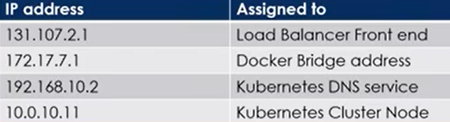

You need to provide internet users with access to the applications that run in Cluster1. Which IP address should you include in the DNS record for Cluster1?

A. 192.168.10.2

B. 172.17.7.1

C. 131.107.2.1

D. 10.0.10.11

**55.** You have an Azure subscription linked to an Azure Active Directory tenant. The tenant includes a user account named User1. You need to ensure that User1 can assign a policy to the tenant root management group.

What should you do?

A. Assign the Global administrator role to User1, and then instruct User1 to configure access management for Azure resources.

B. Create a new management group and delegate User1 as the owner of the new management group.

C. Assign the Owner role for the Azure subscription to User1, and then instruct to configure access management for Azure resources.

D. Assign the Owner role for the Azure Subscription to User1, and then modify the default conditional access policies.

**56.**  You have an Azure Storage account named storage1 that uses Azure Blob storage and Azure File storage. You need to use AzCopy to copy data to the blob storage and file storage in storage1. Which authentication method should you use for each type of storage?

To answer, select the appropriate options in the answer area.

Blob Storage: 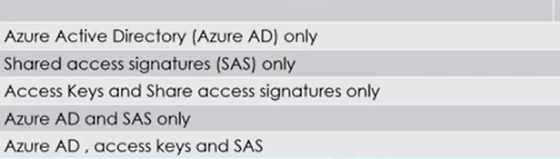

File storage: 

**57.** You have an Azure subscription linked to an Azure Active Directory tenant. The tenant includes a user account named User1. You need to ensure that User1 can assign a policy to the tenant root management group. What should you do?

A. Assign the Global administrator role to User1, and then instruct User1 to configure access management for Azure resources.

B. Create a new management group and delegate User1 as the owner of the new management group.

C. Assign the Owner role for the Azure subscription to User1, and then instruct User1 to configure access management for Azure resources.

D. Assign the Owner role for the Azure Subscription to User1, and then modify the default conditional access policies.

**58.** You have an Azure subscription that contains a virtual machine named VM1. VM1 hosts a line-of-business application that is available 24 hours a day. VM1 has one network interface and one managed disk. VM1 uses the Dsv3 size.

You plan to make the following changes to VM1:

* Change the size to Dpsv5.
* Add a 500-GB managed disk.
* Add the Puppet Agent extension.
* Enable Desired State Configuration Management.

Which change will cause downtime for VM1?

A. Add the Puppet Agent extension

B. Add a 500-GB managed disk

C. Change the size to Dpsv5

D. Enable Desired State Configuration Management

**59.** You have an Azure subscription that contains a web app named webapp1. You need to add a custom domain named www.contoso.com to webapp1.

What should you do first?

A. Create a DNS record.

B. Upload a certificate.

C. Add a connection string.

D. Stop webapp1.

**60.** You deploy an Azure Kubernetes Service (AKS) cluster named AKS1. You need to deploy a YAML file to AKS1.

**Solution:** From Azure CLI, you run the kubectl client.

Does this meet the goal?

A. Yes

B. No

**61.** You have an Azure subscription that contains a Azure Kubernetes Service (AKS) cluster named AKS1. The autoscaling feature is enabled. You need to configure the minimum and maximum node counts for AKS1. Which cmdlet should you use?

A. Set-AzAksCluster

B. Start-AzAksCluster

C. Update-AzAksNodePool

D. Set-AzAksClusterCredential

**62.** You have an Azure subscription that contains a Azure Container app named containerapp1. You plan to add scaling rules to containerapp1. You need to ensure that containerapp1 replicas are created based on received messages in the Azure service bus. Which scale trigger should you use?

A. HTTP driven

B. Event driven

C. Memory Usage

D. CPU Usage

<https://learn.microsoft.com/en-us/azure/container-apps/scale-app?pivots=azure-cli>

**63.** You have an Azure subscription that contains two Log Analytics workspaces name Workspace1 and Workspace2 and 100 virtual machines that run Windows Server. You need to collect performance data and events from the virtual machines. The solution must meet the following requirements:

* Logs must be sent to Workspace1 and Workspace 2.
* All Windows events must be captured.
* All security events must be captured.

What should you install and configure on each virtual machine?

A. Windows Azure diagnostics extension (WAD)

B. Azure Monitor agent

C. Windows VM agent

**64.** You have an Azure subscription that uses the public IP addresses shown in the

following table.

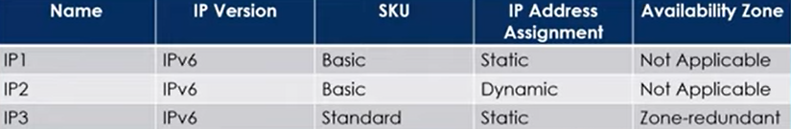

You need to create a public Azure Standard Load Balancer. Which public IP addresses can you use?

1. IP2 only
2. IP3 only
3. IP1 and IP3 only
4. IP1, IP2 and IP3

**65.** Your company has a series of virtual machines created as part of their Azure subscription. They want to ensure the IT administrative team is notified if any of the virtual machines go into the "deallocated" state. Which of the following could you perform to fulfill this requirement?

A. Enable Diagnostics logs for the virtual machine.

B. Create an alert based on the Activity log for the virtual machine.

C. Assign a resource tag for the virtual machine and then create an alert based on that resource tag.

D. Create an Azure policy using an in-built definition from the compute category.

**66.** Your company has an azure subscription that includes a storage account, a resourcegroup, a blob container and a file share. A colleague named Jim Taylor makes useof a solitary Azure Resource Manager (ARM) template to deploy a virtual machineand an additional Azure Storage account. You want to review the ARM templatethat was used by Jim Taylor.

**Solution:** You access the Virtual Machine blade.

Does the solution meet the goal?

A. Yes

B. No

**67.** Your company has an Azure Active Directory (Azure AD) tenant named devopshub2023.com. Company has appointed User1 to review all the settings of the tenant. As an admin your job is to ensure that the User1 can review all the settings of the tenant however User1 must be prevented from changing any settings. Which role should you assign to User1?

A. Security reader

B. Directory reader.

C. Global reader

D. Reports reader

**68.** You have an Azure Active Directory (Azure AD) tenant namedcontoso.onmicrosoft.com that contains 100 user accounts. You purchase 20 AzureAD Premium P2 licenses for the tenant. You need to ensure that 20 users can useall the Azure AD Premium features. What should you do?

A. From the Licenses blade of Azure AD, assign a license.

B. From the Directory role blade of each user, modify the directory role.

C. From the Azure AD domain, add an enterprise application.

D. From the Groups blade of each user, invite the users to a group.

**69.** You have a sync group named Sync1 that has a cloud endpoint. The cloud endpoint includes a file named File1.txt. Your on-premises network contains servers that run Windows Server 2019. The servers are configured as shown in the following table.

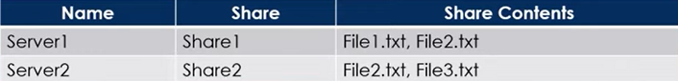

You add Share1 as an endpoint for Sync1. One hour later, you add Share2 as an

endpoint for Sync1. For each of the following statements, select Yes if the

statement is true. Otherwise, select No.

**Statement1 :** On the cloud endpoint, File1.txt is overwritten by File1.txt from Share 1

1. Yes
2. No

**Statement2 :** On Server1, File1.txt is overwritten by File1.txt from Cloud endpoint.

1. Yes
2. No

**Statement3 :** File1.txt from Share1 replicates to Share2

1. Yes
2. No

**70.** Development team for your Project asks you to provision an Azure storage accountfor their use. To remain in compliance with IT security policy, you need to ensurethat the new Azure storage account meets the following requirements:

* Data must be encrypted at rest.
* Access keys must facilitate automatic rotation.
* The company must manage the access keys.

What should you do?

A. Create a service endpoint between the storage account and a virtual network (VNet).

B. Require secure transfer for the storage account.

C. Enable Storage Service Encryption (SSE) on the storage account.

D. Configure the storage account to store its keys in Azure Key Vault.

**71.** You have an Azure subscription that contains the following resources:

* 120 Azure virtual machines
* 20 Azure SQL databases
* 50 Azure file shares

You need to create a daily backup of all the resources by using Azure Backup. What is the minimum number of backup policies that you must create?

A. 1

B. 2

C. 3

D. 150

E. 170

**72.** You have an Azure subscription that has a Recovery Services vault named Vault1.

The subscription contains the virtual machines shown in the following table:

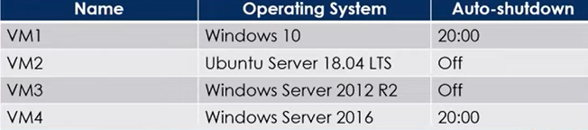

You plan to schedule backups to occur every night at 23:00. Which virtual machines can you back up by using Azure Backup?

A. VM1 only

B. VM1 and VM2 only

C. VM1 and VM3 onlv

D. VM1, VM2, VM3 and VM4

**73.** You administer a solution in Azure that is currently having performance issues. You need to find the cause of the performance issues pertaining to metrics on the Azure infrastructure. Which of the following is the tool you should use to analyze the performance issues?

A. Azure Monitor

B. Azure Activity Log

C. Azure Traffic Analytics

D. Azure Advisor

**74.** You have an Azure subscription named Subscription1 that contains a resource group named RG1. In RG1, you create an internal load balancer named LB1 and a public load balancer named LB2. You need to ensure that an administrator named Admin1 can manage LB1 and LB2. The solution must follow the principle of least privilege. Which role should you assign to Admin1 for each task?

To add a backend pool to LB1: 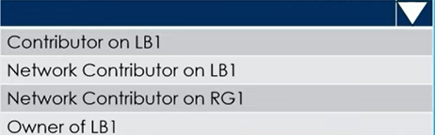

To add a health probe to LB2: 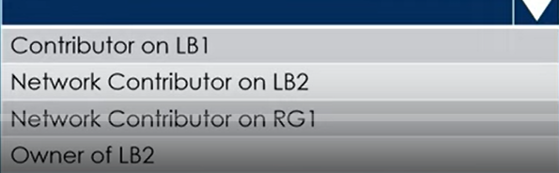

Network Contributer on RG1.

**75.** You have an Azure DNS zone named devopshub.com. You need to delegate a subdomain named cicd.devopshub.com to a different DNS server in Azure.

What should you do?

A. Create a PTR record named cicd in the devopshub.com zone

B. Create a NS record named cicd in the devopshub.com zone

C. Create an A record named *. cicd in the devopshub.com zone

D. Modify the SOA record of devopshub.com

**76.** You have an Azure subscription named Sub1 that contains the Azure resources

shown in the following table.

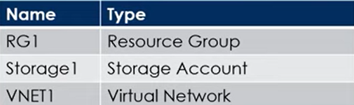

You assign an Azure policy that has the following settings:

* Scope : Sub1
* Exclusions : Sub1/RG1/VNET1
* Policy Definition : Append a tag and its value to resources
* Policy enforcement : Enabled
* Tag name : Tag4
* Tag value : value4

You assign tags to the resources as shown in the following table

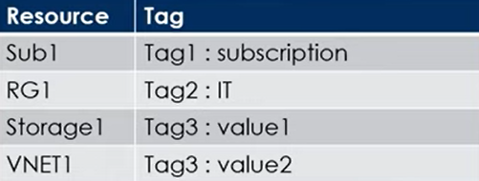

For each of the following statements, select Yes if the statement is true. Otherwise,

select No.

|  |  |
| --- | --- |
| Statements | Yes/No |
| RG1 has the Tag2:IT tag assigned only | Yes |
| Storage1 has the Tag1:subscription, Tag2:IT,  Tag3:value1 and Tag4:value4 tags assigned | No |
| VNET1 has Tag2:IT and Tag3:value2 tags assigned | No |

**77**. You have a hybrid deployment of Azure Active Directory (Azure AD) that contains

the users shown in the following table

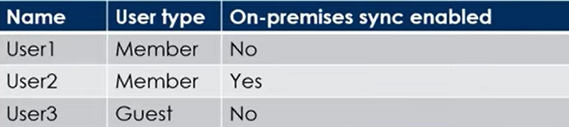

You need to modify the 'JobTitle' and 'UsageLocation' attributes for the users. For

which users can you modify the attributes from Azure AD?

|  |  |
| --- | --- |
| **Job Title** | **UsageLocation** |
|  |  |

**78.** You have an Azure Storage account named storage1. You have an Azure App Service app named App1 and an app named App2 that runs in an Azure container instance. Each app uses a managed identity. You need to ensure that App1 and App2 can read blobs from storage1. The solution must meet the following requirements:

* Minimize the number of secrets used.
* Ensure that App2 can only read from storage1 for the next 30 days.
* What should you configure in storage1 for each app?

|  |  |
| --- | --- |
| **App1** | **App2** |
|  |  |

**79.** You need to create an Azure Storage account that meets the following requirements:

* + Minimizes costs
  + Supports hot, cool, and archive blob tiers
  + Provides fault tolerance if a disaster affects the Azure region where the account resides.

Select the appropriate options to complete the command you should use?

az storage account create -g RG1-n storageaccount1 -- kind 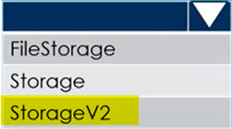

-- sku 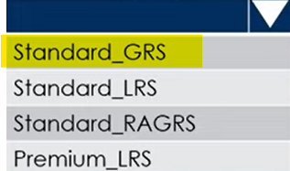

**80.** You plan to use the Azure Import/Export service to copy files to a storage account. Which two files should you create before you prepare the drives for the import job?

A. a dataset CSV file

B. an XML manifest file

C. a JSON configuration file

D. a driveset CSV file

E. a PowerShell PS1 file

**81.** You create an Azure Storage account. You plan to add 15 blob containers to the storage account. For one of the containers, you need to use a different key to encrypt data at rest. What should you do before you create the container?

A. Modify the minimum TLS version

B. Rotate the access keys

C. Create an encryption scope

D. Generate a shared access signature (SAS)

**82.** You have an Azure subscription. You plan to deploy a new storage account. You need to configure encryption for the account and the solution must meet the following requirements:

* Use the maximum supported bit length.
* Use a customer-managed key stored in a key vault.

Which type of key and which bit length should you use?

|  |  |
| --- | --- |
| **Key** | **Bit Length** |
|  |  |

**83.** You have an Azure Load Balancer named LB1. You assign a user named User1 the roles shown in the following exhibit.

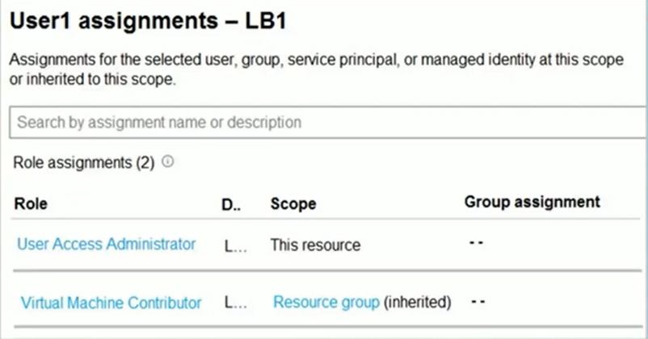

Select the answer choice that completes each statement based on the informat

presented in the graphic shown on previous slide

User1 can 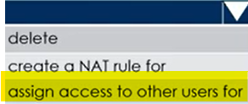 LB1

User1 can 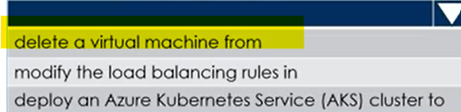 the resource group

**84.** You recently created a new Azure subscription that contains a user named Admin1. Admin1 attempts to deploy an Azure Marketplace resource by using an Azure Resource Manager template. Admin1 deploys the template by using Azure PowerShell and receives the following error message: 'User failed validation to purchase resources. Error message: 'Legal terms have not been accepted for this item on this subscription. To accept legal terms, please go to the Azure portal (http://go.microsoft.com/fwlink/?Linkld=534873) and configure programmatic deployment for the Marketplace item or create it there for the first time.' You need to ensure that Admin1 can deploy the Marketplace resource successfully.

What should you do?

A. From Azure PowerShell, run the Set-AzApiManagementSubscription cmdlet

B. From Azure PowerShell, run the Set-AzMarketplaceTerms cmdlet

C. From the Azure portal, register the Microsoft.Marketplace resource provider

D. From the Azure portal, assign the Billing /administrator role to Admin1

**85.** You have an Azure subscription that contains the resources shown in the following

table:

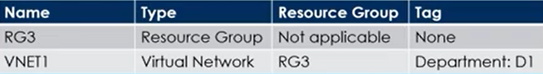

You assign a policy to RG3 as shown in the following table:

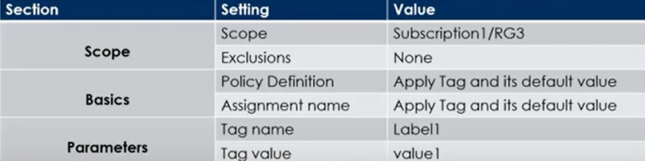

To RG3. vou apply the tag: RGroup: RG3.

You deploy a virtual petwork named VNET2 to RG3

Which tags apply to VNET1 and VNET2? To answer, select the appropriate option below .

VNET1 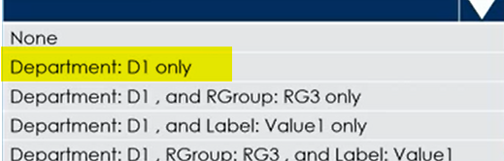

VNET2 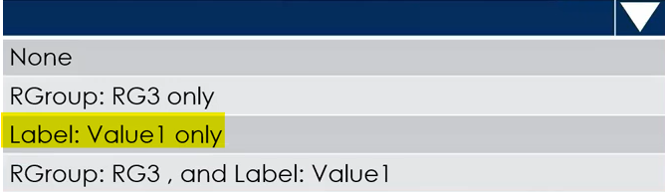

**86.** You have an Azure subscription that contains the resources shown in the following

table.

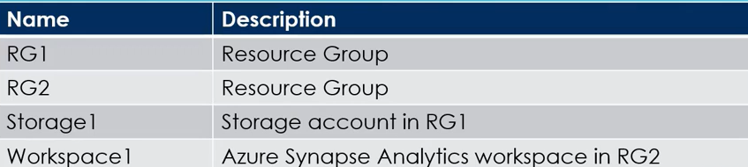

You need to assign Workspace1 a role to allow read, write, and delete operations for the data stored in the containers of storage1. Which role should you assign?

A. Reader and Data Access

B. Storage Account Contributor

C. Contributor

D. Storage Blob Data Contributor

**87.** You have an Azure AD tenant that contains the groups shown in the following table.

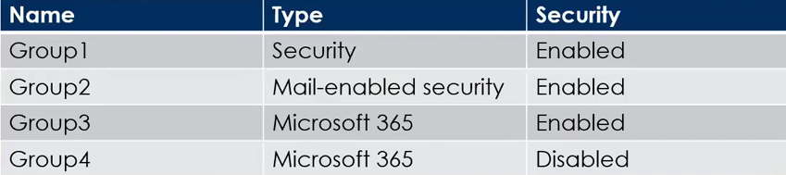

You purchase Azure Active Directory Premium P2 licenses. To which groups can you assign a license?

A. Group1 only

B. Group1 and Group3 only

C. Group3 and Group4 only

D. Group1, Group2, and Group3 only

E. Group1, Group2, Group3, and Group4

**88.** You have an Azure subscription that contains a storage account named storage1. You have the devices shown in the following table.

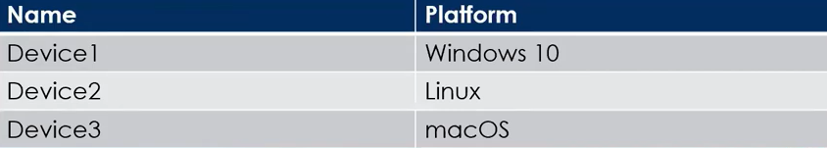

From which devices can you use AzCopy to copy data to storage1?

A. Device 1 only

B. Device1 and Device2 only

C. Device1 and Device3 only

D. Device1, Device2 and Device3

**89.** You have an Azure subscription. The subscription contains a storage account named storage1 that has the lifecycle management rules shown in the following table.

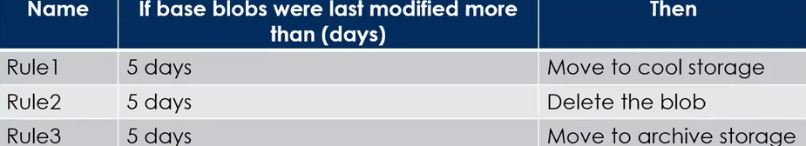

On July 1, you store a blob named File1 in the Hot access tier of storage1. What is the state of File1 on July 7?

A. Stored in the Hot access tier

B. Stored in the Cool access tier

C. Stored in the Archive access tier

D. Deleted

**89.** You plan to deploy an Azure container instance by using the following Azure

Resource Manager template.

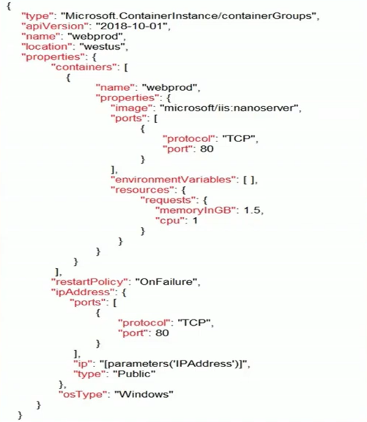

Use the drop-down menus to select the answer choice that completes each statement based on the information presented in the template.

Internet users 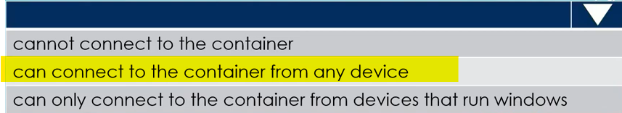

If Internet Information Services on container fails 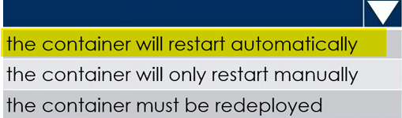

**90.** You have an Azure Subscription. You plan to deploy the Azure container instances shown in the following table.

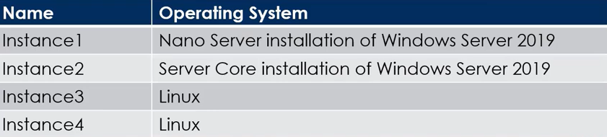

Which instances can you deploy to a container group?

A. Instance1 only

B. Instance2 only

C. Instance1 and Instance2 only

D. Instance3 and Instance4 only

**91.** You have two Azure virtual networks named VNet1 and VNet2. VNet1 contains an Azure virtual machine named VM1. VNet2 contains an Azure virtual machine named VM2. VM1 hosts a frontend application that connects to VM2 to retrieve data. Users report that the frontend application is slower than usual. You need to view the average round-trip time (RTT) of the packets from VM1 to VM2. Which Azure Network Watcher feature should you use?

A. Connection troubleshoot

B. Connection monitor

C. NSG flow logs

D. IP flow verify

**92.** How can you efficiently transfer hundreds of terabytes of media files from your organization's online library to Azure, given the limited bandwidth of your datacenter? Your solution should be fast, cost-effective, and dependable, and it must ensure 256-bit encryption. What choice will you make?

A. Data Box Edge

B. Upload using Azure portal

C. Import/Export

D. Data Box Heavy

**93.** You have an Azure subscription. You create the Azure Storage account shown in the following exhibit.

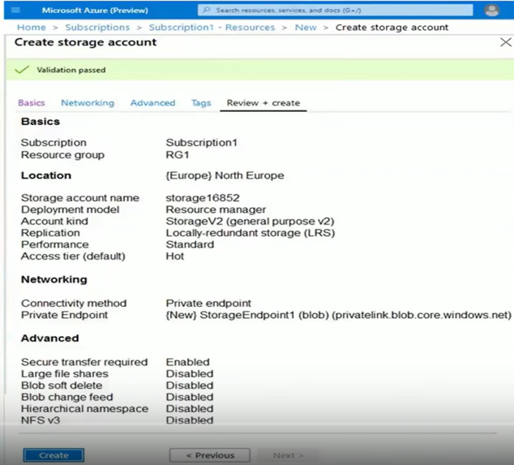

Select the answer choice that completes each statement based on the information provided in screenshot in previous tab.

The minimum number of copies of the storage account will be 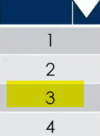

To reduce the cost of infrequently accessed data in the storage account, you must modify the 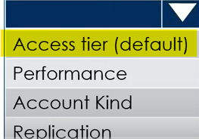 setting.

**94.** You have an Azure web app named App1. App1 has the deployment slots shown ir

the following table:

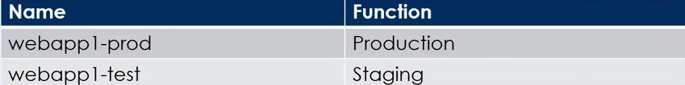

you test several changes to App1 in webapp1-test. You back up App1. You swap webapp1-test for webapp1-prod and discover that App1 is experiencing performance issues. You need to revert to the previous version of App1 as quickly as possible. What should you do?

A. Clone App1

B. Redeploy App1

C. Swap the slots

D. Restore the backup of App1

**95.** Your company wants to move all services to Azure Kubernetes service as part of application modernization. Which two of the following components contributes to the monthly Azure charge?

A. Networking resources

B. Per deployed pod

C. Master node

D. Per node VM

**96.** Your Azure subscription contains an Azure Storage account. You need to create an Azure container instance named container1 that will use a Docker image named Image1. Image1 contains a Microsoft SQL Server instance that requires persistent storage. You need to configure a storage service for Container1. What should you use?

A. Azure Blob storage

B. Azure Files

C. Azure Queue storage

D. Azure Table storage

**97.** You have Azure Active Directory tenant named Contoso.com that includes

following users:

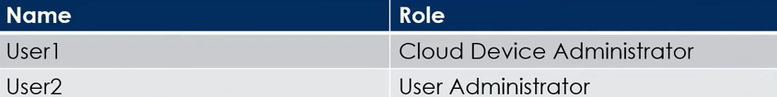

Contoso.com includes following Windows 10 devices:

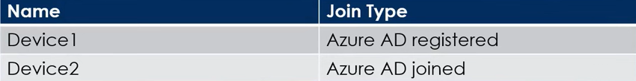

You create following security groups in Contoso.com:

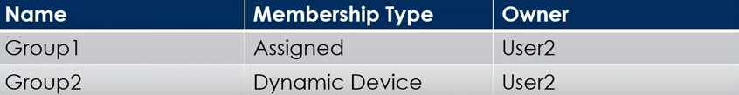

For each of the following statements, select Yes if the statement is true. Otherwise,

select No.

|  |  |
| --- | --- |
| **Statement** | **Yes/No** |
| User1 can add Device2 to Group1 | No |
| User2 can add Device1 to Group1 | Yes |
| User2 can add Device2 to Group2 | No |

**98.** You create the following resources in a subscription:

* An Azure Container Registry instance named Registry1.
* An Azure Kubernetes Service (AKS) cluster named Cluster1.

You create a container image named App1 on your administrative workstation. You need to deploy App1 to cluster1. What should you do first?

A. Run the kubect1 apply command.

B. Run the az aks create command.

C. Run the docker push command.

D. Create a host pool on Cluster1.

**99.** You have an Azure Storage account named storage1 that contains a blob container. The blob container has a default access tier of Hot. Storage1 contains a container named container1. You create lifecycle management rules in storage1 as shown in the following table.

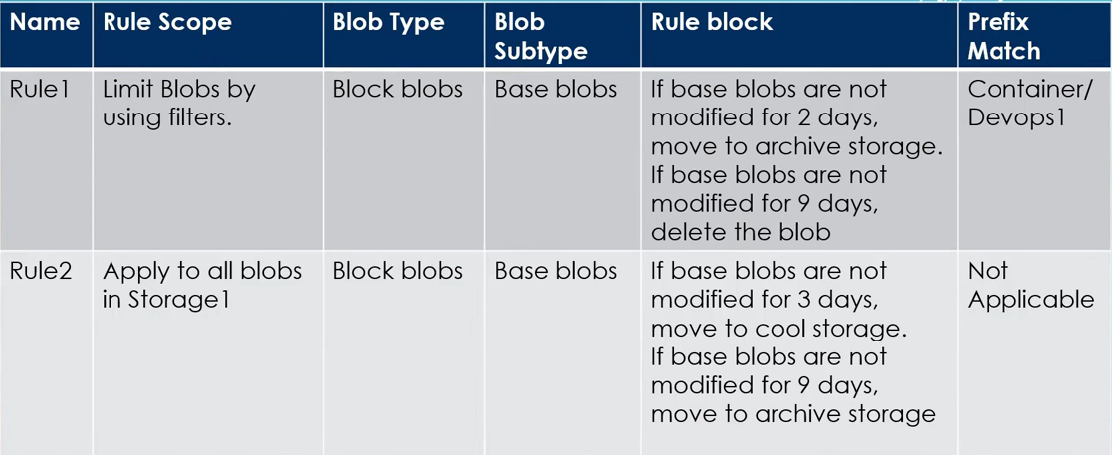

You perform the actions shown in the below table.

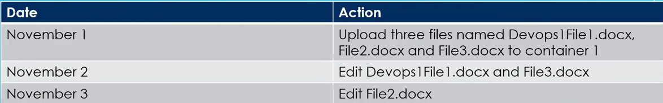

For each of the following statements, select Yes if the statement is true. Otherwise select No.

|  |  |
| --- | --- |
| **Statement** | **Yes/No** |
| On November 10, You can read Devops1File1.docx | No |
| On November 10, You can read File2.docx | Yes |
| On November 10, You can read File3.docx | Yes |

**100.** Which two of the following are an elements of Template schema?

A. Parameters

B. Includes

C. Outputs

D. Scripts

**101.** You have an Azure virtual machine (VM) that has a single data disk. You have been tasked with attaching this data disk to another Azure VM. You need to make sure that your strategy allows for the virtual machines to be offline for the least amount of time possible. Which of the following is the action you should take first?

A. Stop the VM that the data disk must be attached to.

B. Detach the data disk.

C. Delete the VM that includes the data disk.

D. Stop the VM that includes the data disk.

**102.** You have an Azure subscription that contains a storage account named storage1. The storage1 account contains a file share named share1. The subscription is linked to a hybrid Azure Active Directory (Azure AD) tenant that contains a security group named Group1. You need to grant Group1 the Storage File Data SMB Share Elevated Contributor role for share1. What should you do first?

A. Grant share-level permissions by using File Explorer

B. Mount share1 by using File Explorer

C. Create a private endpoint.

D. Enable Azure Active Directory Domain Service (AD DS) authentication for storage1.

**103.** Your on-premises network contains a VPN gateway. You have an Azure subscription that contains the resources shown in the following table:

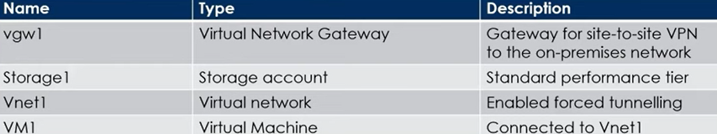

You need to ensure that all the traffic from VM1 to storage1 travels across the Microsoft backbone network. What should you configure?

A. Azure Virtual WAN

B. Private endpoints

C. Azure Application Gatewav

D. A network security group (NSG)

**104.** You have an Azure AD tenant. You need to create a Microsoft 365 group that contains only members of Marketing department in Egypt. How should you complete the dynamic membership rule? To answer, select the appropriate options in the below command

( 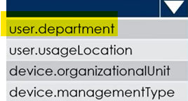 -eq “Marketing”) 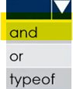(user.country 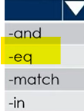 “Egypt”)

**105.** You have an Azure subscription that contains a storage account named storage1. The storage1 account contains a container named container1. You create a blob lifecycle rule named rule1. You need to configure rule1 to automatically move blobs that were NOT updated for 45 days from container to the Cool access tier. How should you complete the rule? To answer, select the appropriate options

"tierToCool": {

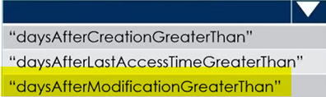:45

}

“filters”: {

“blobTypes”:[

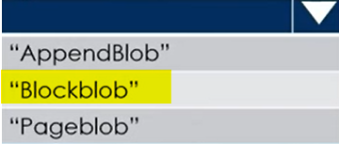

]

**106.** You have an Azure subscription that contains a virtual machine named VM1. You plan to add a 1-TB data disk to VM1 that meets the following requirements:

* + Provides data resiliency in the event of a datacenter outage.
  + Ensures that no data loss occurs if a host fails.
  + Provides the lowest latency and the highest performance.

You need to recommend which type of storage and host caching to configure for the new data disk. What will be your recommendation?

**Storage Type :**

A. Premium SSD that uses locally-redundant Storage (LRS)

B. Premium SSD that uses zone-redundant Storage (ZRS)

C. Standard SSD that uses locally-redundant Storage (LRS)

D. Standard SSD that uses zone-redundant Storage (ZRS)

**Host Caching :**

A. None

B. Read-only

C. Read/Write

**107.** You have an Azure virtual machine named VM1. VM1 was deployed by using a custom Azure Resource Manager template named ARM1.json. You receive a notification that VM1 will be affected by maintenance. You need to move VM1 to a different host immediately.

**Solution:** From the Update management blade, you click Enable.

Does this meet the goal?

A. Yes

B. No

**108.** You have an Azure Storage account named storage1 that contains a blob container named container1. You need to prevent new content added to container1 from being modified for one year. What should you configure?

A. the access level

B. the access tier

C. an access policy

D. the Access control (IAM) settings

**109.** You have an Azure subscription. You are deploying an Azure Kubernetes Service (AKS) cluster that will contain multiple pods. The pods will use Kubernetes networking. You need to restrict network traffic between the pods. What should you configure on the AKS cluster?

A. Azure network policy

B. Calico network policy

C. pod security policies

D. application security group

**110.** You host a service with two Azure virtual machines. You discover that occasional outages cause your service to fail. What two actions can you do to minimize the impact of the outages?

A. Put the virtual machines in a scale set.

B. Add a network gateway.

C. Add a load balancer.

D. Add a third instance of the virtual machine.

E. Put the virtual machines in an availability set.

**111.** You have an Azure subscription named Subscription1. In Subscription1, you create an alert rule named Alert1. The Alert1 action group is configured as shown in the following exhibit.

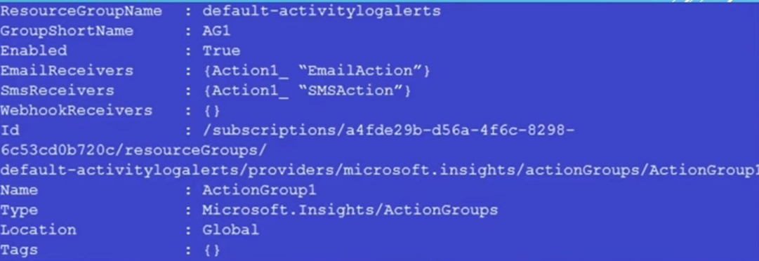

Alert1 alert criteria is to be triggered every minute. Select the answer choice that completes each statement based on the information presented in the graphic.

The number of email messages that Alert1 will send in an hour is 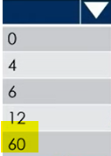

The number of sms messages that Alert1 will send in an hour is 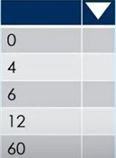

**112.** You have Azure subscription that includes following Azure file shares:

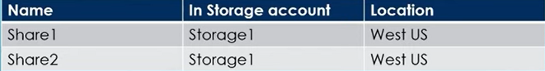

You have the following on-premises servers:

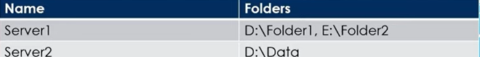

You create a Storage Sync Service named Sync1 and an Azure File Sync group named Group1. Group1 uses Share1 as a cloud endpoint. You register Server1 and Server2 in Sync1. You add D:Folder1 on Server1 as'a server endpoint of Group1. For each of the following statements, select Yes if the statement is true. Other select No.

**Statement1:** Share2 can be added as a cloud endpoint for Group1 Yes/No

**Statement2:** D:Data on Server2 can be added as a server endpoint for Group1 Yes/ No

**Statement3:** E:\Folder2 on Server1 can be added as a server endpoint for Group1 Yes/No

**113.** You have an Azure subscription that contains 10 virtual networks. The virtual networks are hosted in separate resource groups. Another administrator plans to create several network security groups (NSGs) in the subscription. You need to ensure that when an NSG is created, it automatically blocks TCP port 8080 between the virtual networks.

**Solution:** From the Resource providers blade, you unregister the Microsoft.ClassicNetwork provider.

Does this meet the goal?

A. Yes

B. No

**114.** You have a production Azure Active Directory (Azure AD) tenant named contoso.com. You deploy a development Azure Active Directory (AD) tenant, and then you create several custom administrative roles in the development tenant. You need to copy the roles to the production tenant. What should you do first?

A. From the production tenant, create a new custom role.

B. From the production tenant, create an administrative unit.

C. From the development tenant, export the custom roles to JSON.

D. From the development tenant, perform a backup.

**115.** You plan to use Azure Network Watcher to perform the following tasks:

* Task1: Identify a security rule that prevents a network packet from reaching an Azure virtual machine.
* Task2: Validate outbound connectivity from an Azure virtual machine to an external host.

Which feature should you use for each task? To answer, select the appropriate options below :

**Task 1:** 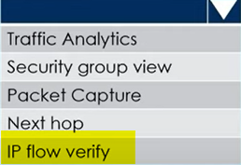

**Task 2:** 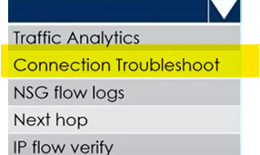

**116.** You have deployed an application named App1 in Azure. App1 is deployed on two Azure virtual machines named VM1 and VM2. You plan to implement an Azure Availability Set for App1. The solution must ensure that App1 is available during planned maintenance of the servers hosting VM1 and VM2. What should you include in the Availability Set?

A. Single update domain

B. Single fault domain

C. Two update domains

D. Two fault domains

**117.** You have deployed an application named App1 in Azure. App1 is deployed on two Azure virtual machines named VM1 and VM2. You plan to implement an Azure Availability Set for App1. The solution must ensure that App1 is available during unplanned maintenance of the servers hosting VM1 and VM2. What should you include in the Availability Set?

A. Single update domain

B. Single fault domain

C. Two update domains

D. Two fault domains

**118.** You manage a virtual network named VNet1 that is hosted in the East US Azure region. VNet1 hosts two virtual machines named VM1 and VM2 that run Windows Server. You need to inspect all the network traffic from VM1 to VM2 for a period of three hours.

**Solution:** From Azure Network Watcher, you create a packet capture.

Does this meet the goal?

A. Yes

B. No

**119.** You have an Azure subscription that contains the public load balancers shown in the following table.

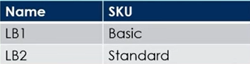

You plan to create six virtual machines and to load balance requests to the virtual machines. Each load balancer will load balance three virtual machines. You need to create the virtual machines for the planned solution. How should you create the virtual machines? To answer, select the appropriate options below :-

**The Virtual Machines that will be load balanced by using LB1 must:**

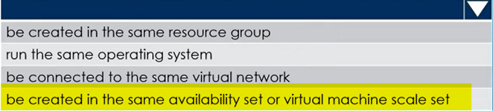

**The Virtual Machines that will be load balanced by using LB2 must:**

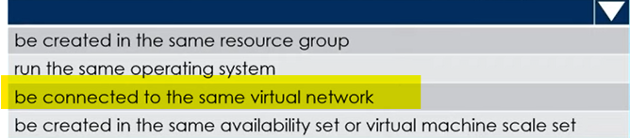

**120.** You have a script that creates several VM's with different images. When the script issues the command to create the first VM you do not want to block the script while the VM is created, instead you want the script to immediately move on to the next command. What is the best way to do this?

A. Use the ampersand (&) to run the process in the background.

B. Add the ' -- no-wait' argument to your create command.

C. Add the ' -- async' argument to your create command.

**121.** You have an Azure subscription. You plan to deploy an Azure Kubernetes Service (AKS) cluster to support an app named App1. On-premises clients connect to App1 by using the IP address of the pod. For the AKS cluster, you need to choose a network type that will support App1. What should you choose?

A. Hybrid Connection endpoints

B. Azure Private Link

C. Kubenet

D. Azure Container Networking Interface (CNI)

**122.** You have an Azure subscription named Subscription1. Subscription1 contains th

resources in the following table.

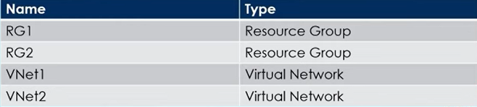

VNet1 is in RG1, VNet2 is in RG2 and there is no connectivity between VNet1 and VNet2. An administrator named Admin1 creates an Azure virtual machine named VM1 in RG1. VM1 uses a disk named Disk1 and connects to VNet1. Admin1 then installs a custom application in VM1. You need to move the custom application to VNet2 and the solution must minimize administrative effort. Which two actions should you perform? To answer, select the appropriate answer among the options provided.

**First Action:** 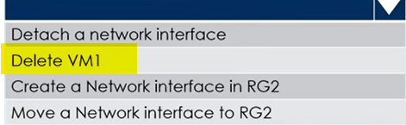

**Second Action:** 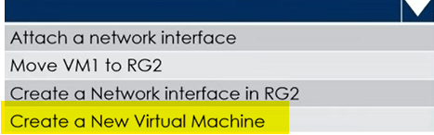

**123**. You have an Azure subscription that contains an Azure Storage account named storageaccount1. You export storageaccount1 as an Azure Resource Manager template.

The template contains the following sections.

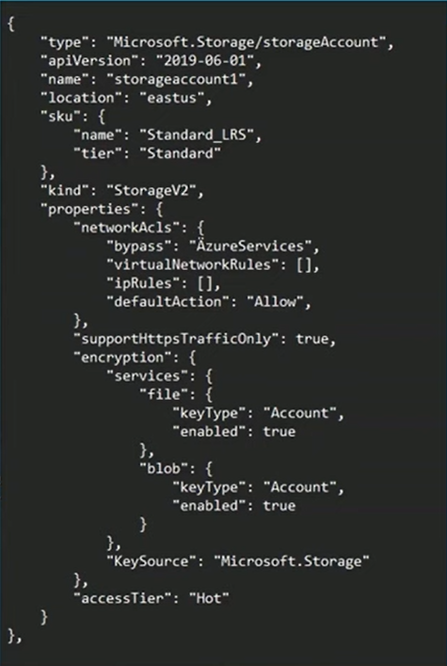

For each of the following statements, select Yes if the statement is true. Otherwise, select No

**Statement1:** A Server that has a Public IP address of 131.107.103.10 can access storageaccount1.

Yes/No

**Statement2:** Individual blobs in storageaccount1 can beset to use the archive tier.

Yes/No

**Statement3:** Global Administrators in Azure Active Directorycan access a file share hosted in storageaccount1by using their Azure AD credentials.

Yes/No

**124.** You onboard 10 Azure virtual machines to Azure Automation State Configuration and you need to use Azure Automation State Configuration to manage the ongoing consistency of the virtual machine configurations. Which three actions should you perform in sequence?

1. Create a Management Group

2. Check the compliance status of the node **3**

3. Assign tags to the Virtual machines.

4. Compile configuration into node configuration **2**

5. Import configuration to Azure automation State configuration **1**

**125.** You have a Azure virtual network named VNet1 that contains a subnet named Subnet1. Subnet1 contains 3 Azure virtual machines and each virtual machine has a public IP address. The virtual machines host several applications that are accessible over port 443 to users on the Internet. Your on-premises network has a site-to-site VPN connection to VNet1 and you discover that the VM's can be accessed over RDP from Internet and from on-premises network. You need to prevent RDP access to the virtual machines from the Internet, unless the RDP connection is established from the on-premises network. The solution must ensure that all the applications can still be accessed by the Internet users.

How can you achieve this requirement?

A. Create a deny rule in a network security group (NSG) that is linked to Subnet1

B. Modify the address space of Subnet1.

C. Modify the address space of the local network gateway.

D. Remove the public IP addresses from the virtual machines.

**126.** You have an Azure subscription that contains two on-premises locations named site1 and site2. You need to connect site1 and site2 by using an Azure Virtual WAN. Which of the following four actions should you perform in sequence?

1. Create a Virtual WAN Resource. **1**

2. Create VPN Sites.  **3**

3. Connect the VPN sites to the hub. **4**

4. Create a Virtual Hub. **2**

5. Connect the Virtual networks to the hub

**127.** You have an Azure subscription. Users access the resources in the subscription from either home or from customer sites. From home, users must establish a point-to-site VPN to access the Azure resources. The users on the customer sites access the Azure resources by using site-to-site VPNs. You have a line-of-business- app named App1 that runs on several Azure virtual machine. The virtual machines run Windows Server 2019. You need to ensure that the connections to App1 are spread across all the virtual machines. What are two possible Azure

services that you can use?

A. Traffic Manager

B. Public load balancer

C. Azure Content Delivery Network

D. Azure Application Gateway

E. Internal load balancer

**128.** You have a pay-as-you-go Azure subscription that contains the virtual machines

shown in the following table.

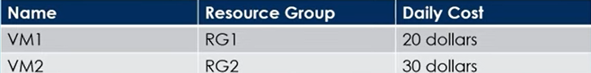

You create the budget shown in the exhibit below.

|  |  |
| --- | --- |
| The AG1 action group contains a user named [admin@contoso.com](mailto:admin@contoso.com) only. Select the answer choice that completes each statement based on the information presented in the graphic. |  |

When the maximum amount in Budget1 is reached 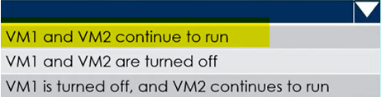

Based on the current usage costs of the virtual machines 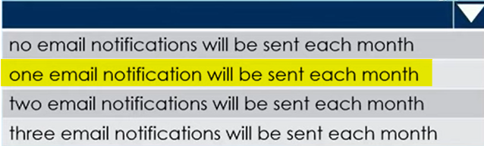

**129.** You have an Azure subscription that contains the resources as shown below

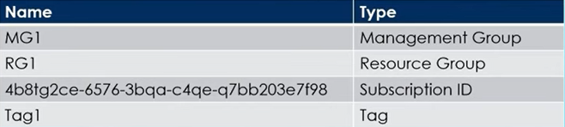

In Azure Cloud Shell, you need to create a virtual machine by using an Azure Resource Manager (ARM) template. How should you complete the command?

$adminPassword =Read-Host -Prompt "Enter the Admin Password" -AsSecureString

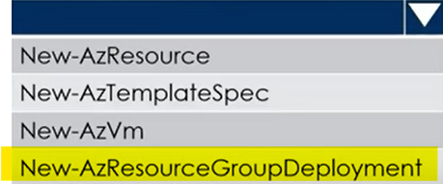 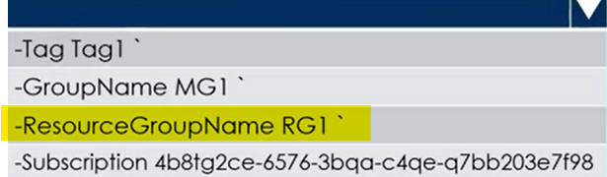

-TemplateUri https://raw.githubusercontent.com/azure-templates/azuredeploy.json

-adminUsername LocalAdmin -adminPassword $adminPassword -dnsLabelPrefix TestVM1

**130.** You have a Azure virtual network named VNet1 that contains a subnet named Subnet1. Subnet1 contains 3 Azure virtual machines and each virtual machine has a public IP address. The virtual machines host several applications that are accessible over port 443 to users on the Internet. Your on-premises network has a site-to-site VPN connection to VNet1 and you discover that the VM's can be accessed over RDP from Internet and from on-premises network. You need to prevent RDP access to the virtual machines from the Internet, unless the RDP connection is established from the on-premises network. The solution must ensure that all the applications can still be accessed by the Internet users.

How can you achieve this requirement?

A. Create a deny rule in a network security group (NSG) that is linked to Subnet1.

B. Modify the address space of Subnet1.

C. Modify the address space of the local network gateway.

D. Remove the public IP addresses from the virtual machines.

**131.** You configure the custom role shown in the following exhibit.

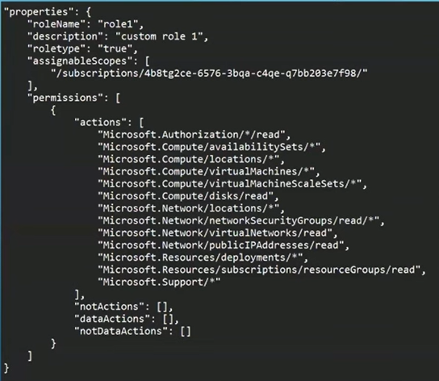

Use the drop-down menus to select the answer choice that completes each statement based on the information presented in the graphic.

To ensure that users can sign in to virtual machines that are assigned role1, modify the 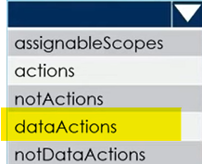 section.

To ensure that role1 can be assigned only to a resource group named RG1, modify the

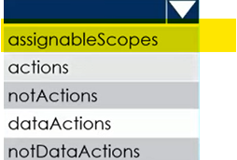section.

**132.** You have an Azure subscription that contains a virtual machine named VM1 and an Azure key vault named KV1. You need to configure encryption for VM1. The solution must meet the following requirements:

* + Maintain encryption if VM1 is downloaded from Azure.
  + Encrypt both the operating system disk and the data disks.
  + Store and use the encryption key in KV1.

Which encryption method should you use?

A. Azure Disk Encryption

B. Customer-managed keys

C. Confidential disk encryption

D. Encryption at host

**133.** You have 10 Azure subscriptions. You have an Azure Active Directory (Azure AD) tenant that contains a security group named Group1 and you plan to purchase additional Azure subscription. You need to ensure that Group1 can manage role assignments for the existing subscriptions and the planned subscriptions. The solution must meet the following requirements:

* Use the principle of least privilege.
* Minimize administrative effort.

What should you do?

A. Create a new management group and assign Group1 the User Access Administrator

role for the group.

B. Create a new management group and assign Group1 the Owner role for the group.

C. Assign Group1 the Owner role for the root management group.

D. Assign Group1 the User Access Administrator role for the root management group.

**134.** You have an Azure subscription that contains a storage account named storage1. Subscription is linked to an Azure AD tenant named contoso.com that syncs to an on-premises Active Directory domain. The domain contains the security principals shown in the following table.

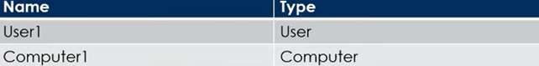

In Azure AD, you create a user named User2. Storage1 account contains a file share named share1 and has the following configurations.

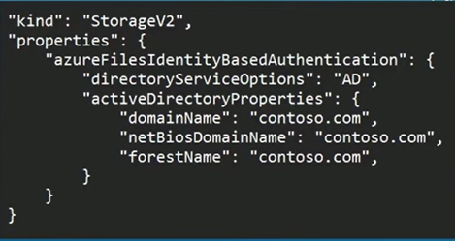

For each of the following statements, select Yes if the statement is true. Otherwise, select No.

**Statement1:**

You can assign the Storage File data SMB Share reader role to Computer1 for Share1 Yes/No

**Statement2:**

You can assign the Storage File data SMB Share Contributor role to User1 for Share1 Yes/No

**135.** You have an Azure App Services web app named App1. You plan to deploy App1 by using Web Deploy. You need to ensure that the developers of App1 can use their Azure AD credentials to deploy content to App1. The solution must use the principle of least privilege. What should you do?

A. Configure user-level credentials for FTPS.

B. Configure app-level credentials for FTPS.

C. Assign the Owner role to the developers.

D. Assign the Website Contributor role to the developers.

**136.** You have an Azure subscription that contains two virtual machines as shown in the following table.

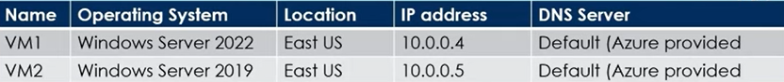

You perform a reverse DNS lookup for 10.0.0.4 from VM2. Which FQDN will be returned?

A. vm1.eastus.cloudapp.azure.com

B. vm1.core.windows.net

C. vm1.internal.cloudapp.net

D. vm1.azure.com

<https://learn.microsoft.com/en-us/azure/virtual-network/virtual-networks-name-resolution-for-vms-and-role-instances?tabs=redhat#reverse-dns-considerations>

**137.** You plan to deploy route-based Site-to-Site VPN connections between several on-premises locations and an Azure virtual network. Which tunneling protocol should you use?

A. PPTP

B. IKEv1

C. IKEv2

D. L2TP

**138.** You have an Azure virtual machine named VM1 that runs Windows Server 2016. You need to create an alert in Azure when more than two error events are logged to the System event log on VM1 within an hour.

**Solution:** You create an Azure Log Analytics workspace and configure the data settings. You install the Microsoft Monitoring Agent on VM1. You create an alert in Azure Monitor and specify the Log Analytics workspace as the source.

Does this meet the goal?

A.Yes

B. No

|  |  |
| --- | --- |
| **139.** You have an Azure subscription that contains the hierarchy shown in the following exhibit. You create an Azure Policy definition named Policy1. To which Azure resources can you assign Policy1 and which Azure resources can you specify as exclusions from Policy1?  You can apply Policy1 to:    Which ones can be excluded from Policy1: |  |

**140.** You have an Azure subscription that contains a storage account named storage1. You plan to use conditions when assigning role-based access control (RBAC) roles to storage1. Which of the following storage1 services support conditions when assigning roles?

A. queues only

B. file shares only

C. containers only

D. tables only

E. files shares and tables only

F. containers and queues only

**141.** You have an Azure subscription named Subscription1 that contains the quotas shown in the following table.

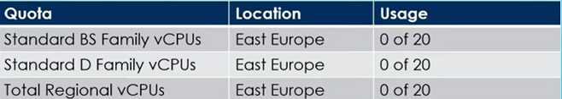

You deploy virtual machines to Subscription1 as shown in the following table.

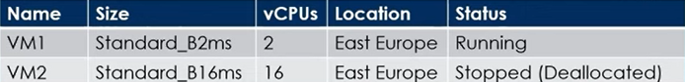

You plan to deploy the virtual machines shown in the following table.

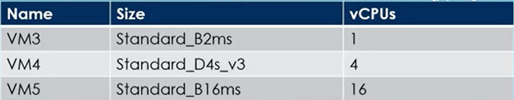

For each of the following statements, select Yes if the statement is true.

Otherwise, select No.

**Statement1:**

You can deploy VM3 to East Europe Yes/No

**Statement2:**

You can deploy VM4 to East Europe Yes/No

**Statement3:**

You can deploy VM5 to East Europe Yes/No

**142.** You have an Azure subscription that contains the resources shown in the following table.

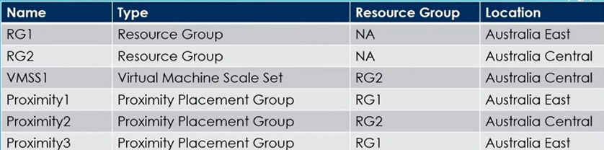

You need to configure a proximity placement group for VMSS1. Which proximity placement groups should you use?

A. Proximity1 only

B. Proximity2 only

C. Proximity1 and Proximity3 only

D. Proximity1, Proximity2 and Proximíty3

**143.** You have an Azure subscription that contains an Azure file share. You have an on-premises server named Server1 that runs Windows Server 2016. You plan to set up Azure File Sync between Server1 and the Azure file share. You need to prepare the subscription for the planned Azure File Sync. Which two actions should you perform in the Azure subscription?

A. Run Server registration

B. Create a Storage Sync Service

C. Install the Azure File Sync agent

D. Create a sync group.

**144.** You have an Microsoft Entra ID tenant named contoso.com that contains the users shown in the following table.

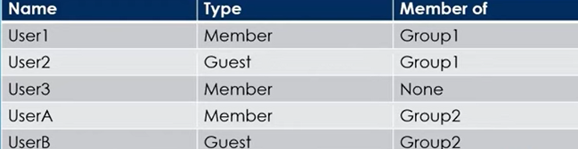

User3 is the owner of Group1. Group2 is a member of Group1. You configure an access review named Review1 shown in the exhibit on next screen.

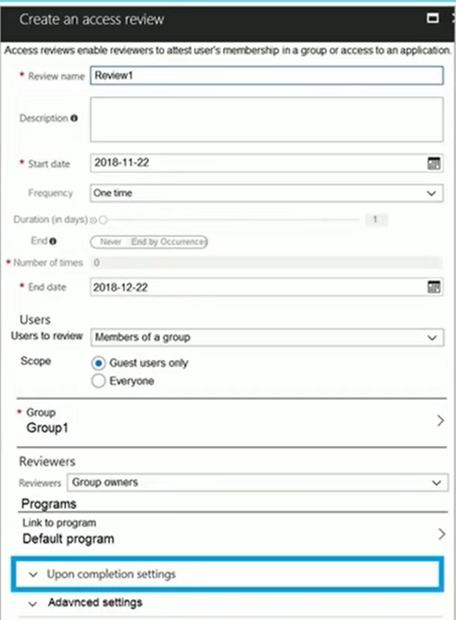

For each of the following statements, select Yes if the statement is true. Otherwise, select No.

**Statement1:**

User3 can perform an access review of UserA. Yes/No

**Statement2:**

User3 can perform an access review of UserB. Yes/No

**Statement3:**

User3 can perform an access review of User1. Yes/No

**145.** You have an Azure subscription named Subscription1 that contains an Azure virtual machine named VM1. VM1 is in a resource group named RG1. VM1 runs services that will be used to deploy resources to RG1. You need to ensure that a service running on VM1 can manage the resources in RG1 by using the identity of VM1. What should you do first?

A. From the Azure portal, modify the Access control (IAM) settings of RG1.

B. From the Azure portal, modify the Policies settings of RG1.

C. From the Azure portal, modify the Managed Identity settings of VM1.

D. From the Azure portal, modify the Access control (IAM) settings of VM1.

**146.** You need to ensure that an Azure Active Directory (Azure AD) user named Admin1 is assigned the required role to enable Traffic Analytics for an Azure subscription.

**Solution:** You assign the Traffic Manager Contributor role at the subscription level to Admin1.

Does this meet the goal?

A. Yes

B. No

**147.** You have two Azure virtual machines named VM1 and VM2 and you have two Recovery Services vaults named RSV1 and RSV2. VM2 is backed up to RSV1 and you need to back up VM2 to RSV2. What should you do first?

A. From the RSV1 blade, click Backup Jobs and export the VM2 job.

B. From the RSV2 blade, click Backup. From the Backup blade, select the backup.

for the virtual machine, and then click Backup.

C. From the RSV1 blade, click Backup items and stop the VM2 backup.

D. From the VM2 blade, click Disaster recovery, click Replication settings, and

then select RSV2 as the Recovery Services vault.

**148.** You have an Azure subscription that contains the resources shown in the following table.

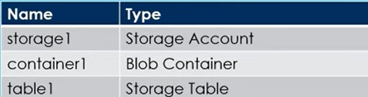

You need to perform the tasks shows in below table

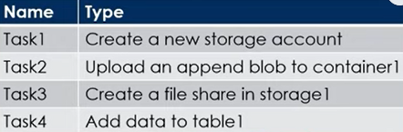

Which tasks can you perform by using Azure Storage Explorer?

A. Task1 and Task3 only

B. Task1, Task2, and Task3 only

C. Task1, Task3, and Task4 only

D. Task2, Task3, and Task4 only

E. Task1, Task2, Task3, and Task4

**149.**  You have three Azure subscriptions named Sub1, Sub2, and Sub3 that are linked to an Entra ID tenant. The tenant contains a user named User1, a security group named Group1, and a management group named MG1. User1 is a member of Group1. Sub1 and Sub2 are members of MG1. Sub1 contains a resource group named RG1. RG1 contains five Azure functions. You create the following role assignments for MG1:

* Group1: Reader
* User1: User Access Administrator

You assign User1 the Virtual Machine Contributor role for Sub1 and Sub2. For each of the following statements, select Yes if the statement is true. Otherwise, select No.

**Statement1:**

User1 can assign the owner role for RG1. Yes/No

**Statement2:**

The Group1 members can view the configurations of the Azure Functions. Yes/No

**Statement3:**

User1 can create a new resource group and deploy a virtual machine to the new group. Yes/No

**150.** You have an Azure subscription named Subscription1 that contains two Azure virtual networks named VNet1 and VNet2. VNet1 contains a VPN gateway named VPNGW1 that uses static routing. There is a site-to-site VPN connection between your on-premises network and VNet1. On a computer named Client1 that runs Windows 10, you configure a point-to-site VPN connection to VNet1. You configure virtual network peering between VNet1 and VNet2. You verify that you can connect to VNet2 from the on-premises network. Client1 is unable to connect to VNet2. You need to ensure that you can connect Client1 to VNet2.

What should you do?

A. Select Allow gateway transit on VNet2.

B. Download and re-install the VPN client configuration package on Client1.

C. Enable BGP on VPNGW1

D. Select Allow gateway transit on VNet1.

**151.** You have five Azure virtual machines that run Windows Server 2019. The virtual machines are configured as web servers. You have an Azure load balancer named LB1 that provides load balancing services for the virtual machines. You need to ensure that visitors are serviced by the same web server for each request. What should you configure?

A. Protocol to UDP

B. Session persistence to Client IP and protocol

C. Floating IP to Enabled

D. Session persistence to None

**152.** You have an Azure subscription named Sub1 that contains the resources shown

the following table.

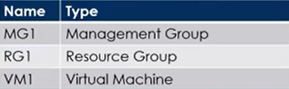

You create a user named Admin1. To what can you add Admin1 as a co-administrator?

A. RG1

B. MG1

C. Sub1

D. VM1

**153.** You have a Microsoft Entra tenant that contains the groups shown in the following table.

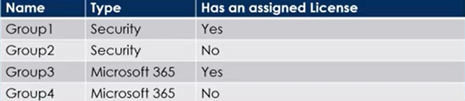

The Tenant contains the users shown in the following table.

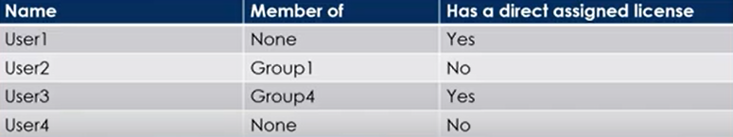

Which users and groups can you delete?

**Users:** 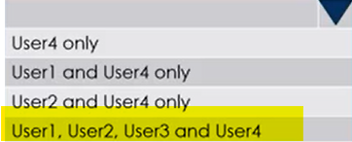

**Groups:** 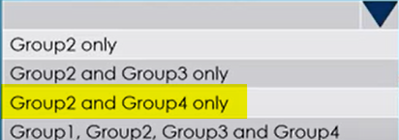

**154.** You have an Microsoft Entra tenant. You plan to delete multiple users by using Bulk delete in the Entra admin center. You need to create and upload a file for the bulk delete. Which user attributes should you include in the file?

A. The user principal name and usage location of each user only

B. The user principal name of each user only

C. The display name of each user only

D. The display name and usage location of each user only

E. The display name and user principal name of each user only

**155.** You have an Azure subscription that contains a resource group named TestRG. You use TestRG to validate an Azure Deployment. TestRG contains the following resources:

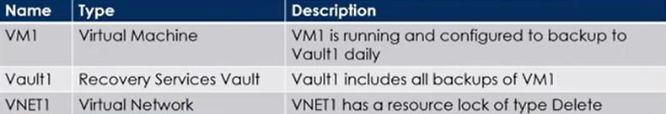

You need to delete TestRG. What should you do first?

A. Modify the backup configurations of VM1 and modify the resource lock type of VNET1

B. Remove the resource lock from VNET1 and delete all data in Vault1

C. Turn off VM1 and remove the resource lock from VNET1

D. Turn off VM1 and delete all data in Vault1

**156.** You have an Azure subscription that contains the resources shown in the following table.

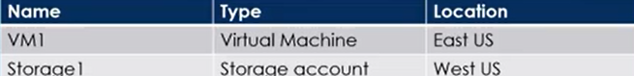

You need to ensure that data transfers between storage1 and VM1 do NOT traverse the internet. What should you configure for storage1?

A. Data Protection

B. A Private endpoint

C. Public network access in the Firewalls and virtual networks settings

D. A shared access signature (SAS)

**157.** You have an Azure virtual machine named VM1 and an Azure key vault named Vault1. On VM1, you plan to configure Azure Disk Encryption to use a key encryption key (KEK). You need to prepare Vault1 for Azure Disk Encryption. Which two actions should you perform on Vault1?

A. Select Azure Virtual machines for deployment.

B. Create a new key.

C. Create a new secret.

D. Configure a key rotation policy.

E. Select Azure Disk Encryption for volume encryption.

**158.** You have an Azure subscription. You plan to create a role definition to meet the following requirements:

* Users must be able to view the configuration data of a storage account.
* Users must be able to perform all actions on a virtual network.
* The solution must use the principle of least privilege.

What should you include in the role definition for each of the below mentioned

requirements?

**Perform all actions on a virtual network:**

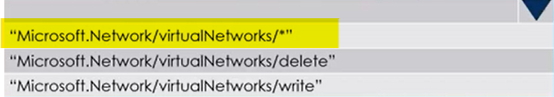

**View the configuration data of a storage account:**

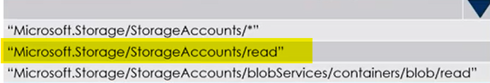

**159.** You have an Azure subscription that contains a storage account named storage1. You need to configure a shared access signature (SAS) to ensure that users can only download blobs securely by name. Which two settings should you configure? To answer, select the appropriate settings below.

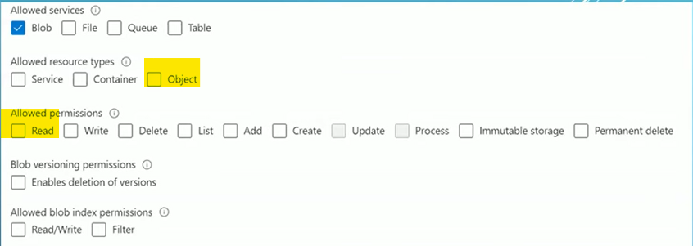

**160.** You need to create an Azure Storage account named storage1. The solution must meet the following requirements:

* Support Azure Data Lake Storage.
* Minimize costs for infrequently accessed data.
* Automatically replicate data to a secondary Azure region.

Which three options should you configure for storage1? Each correct answer presents part of the solution.

A. Zone-redundant storage (ZRS)

B. Cool access tier

C. Geo-redundant storage (GRS)

D. Hot access tier

E. Hierarchical namespace

**161.** You have an Azure subscription that contains the devices shown in the following table.

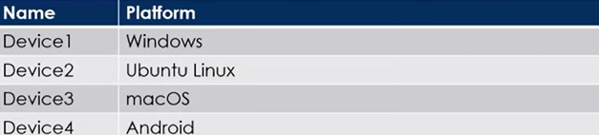

A. Device1 only

B. Device1 and Device2 only

C. Device1 and Device3 only

D. Device1, Device2 and Device3 only

E. Device1, Device3 and Device4 only

**162.** You have an Azure subscription that contains multiple virtual machines in the West US Azure region. You need to use Traffic Analytics in Azure Network Watcher to monitor virtual machine traffic. Which two resources should you create?

A. Log Analytics workspace

B. Azure Monitor workbook

C. Storage account

D. Microsoft Sentinel workspace

E. Data Collection Rule (DCR) in Azure Monitor

**163.** You have an Azure Storage account named storage1 that contains two containers named container1 and container2. Blob versioning is enabled for both containers and you periodically take blob snapshots of critical blobs. You create the following lifecycle management policy

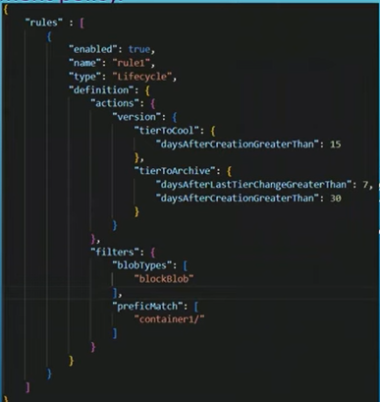.

For each of the following statements, select Yes if the statement is true. Otherwise, select No

**Statement1:**

A Blob Snapshot automatically moves to the Cool access Tier after 15 days Yes/No

**Statement2:**

A Blob version in container2 automatically moves to the Archive access Tier after 30 days Yes/No

**Statement3:**

A rehydrated version in container1 automatically moves to the Archive access tier after 30 days Yes/No

**164.** You have an Azure subscription that contains the virtual networks shown in the following table.

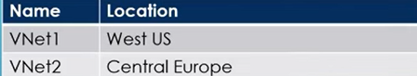

You need to ensure that all the traffic between VNet1 and VNet2 traverses the Microsoft backbone network. What should you configure?

A. Private endpoint

B. Peering

C. Express Route

D. Route table

**165.** You have an Azure subscription and you are creating a new Azure container instance that will have the following settings:

* Container name: cont1
* SKU: Standard
* OS type: Windows
* Networking type: Public
* Memory (GiB): 2.5
* Number of CPU cores: 2

You discover that the Private setting for Networking type is unavailable. You need to ensure that cont1 can be configured to use private networking. Which setting should you change?

A. Memory (GiB)

B. Networking type

C. Number of CPU cores

D. OS type.

**166.** You have an Azure subscription that contains an Azure container registry named ContReg1. You enable the Admin user for ContReg1. Which username can you use to sign in to ContReg1?

A. root

B. admin

C. administrator

D. ContReg1

**167.** You have an Microsoft Entra tenant named devopshub.com. You have an Azure subscription that contains an Azure App Service web app named App1 and an Azure key vault named KV1. KV1 contains a wildcard certificate for devopshub.com. You have a user named user1@devopshub.com that is assigned the Owner role for App1 and KV1. You need to configure App1 to use the wildcard certificate of KV1. What should you do first?

A. Assign a managed user identity to App1.

B. Create an access policy for KV1 and assign the Microsoft Azure App Service principal to the policy.

C. Create an access policy for KV1 and assign the policy to User1.

D. Configure KV1 to use the role-based access control (RBAC) authorization system.

**168.** You have an Azure subscription that contains storage accounts shown in the following table

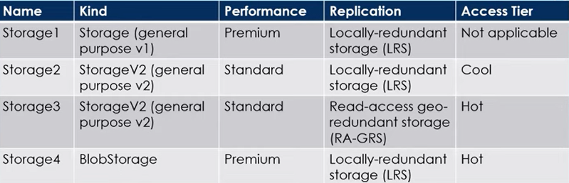

Which storage account can be converted to Zone -redundant (ZRS) replication?

A. Storage1

B. Storage2

C. Storage3

D. Storage4

**169.** You have an Azure subscription that contains the virtual machines shown in the following table

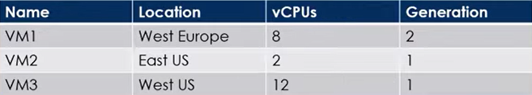

You create an Azure Compute Gallery named ComputeGallery1 as shown in the Azure Compute Gallery exhibit below :

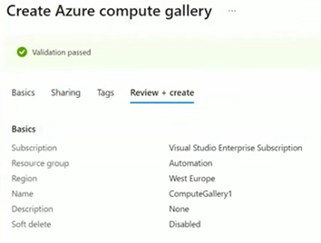

In ComputeGallery1, you create a virtual machine image definition named Image1 as shown in the image definition exhibit.

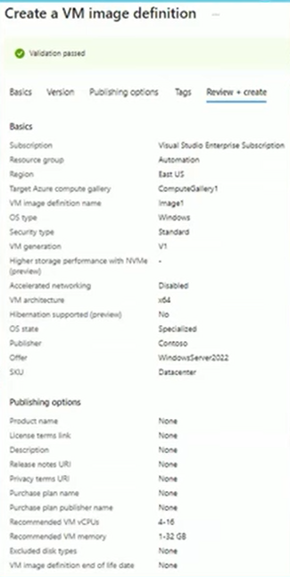

For each of the following statements, select Yes if the statement is true. Otherwise, select No,

**Statement1:**

The Operating System disk of VM1 can be used as a source for a version of Image1 Yes/No

**Statement2:**

The Operating System disk of VM2 can be used as a source for a version of Image1 Yes/No

**170.** You have an Azure subscription that contains the container images shown in the following table.

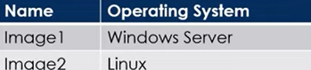

You plan to use the following services:

* Azure Container Instances
* Azure Container Apps
* Azure App Service

In which services can you run the images?

**Image1:** 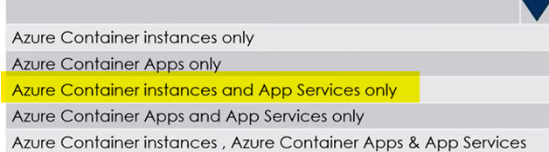

**Image2:** 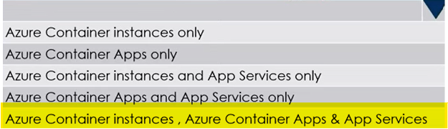

**171.** You have an Azure subscription that contains a resource group named RG1. You plan to create a storage account named storage1.You have a Bicep file named File1. You need to modify File1 so that it can be used to automate the deployment of storage1 to RG1. Which property should you modify?

A. kind

B. scope

C. sku

D. location

**172.** You have an Azure subscription. You plan to deploy the resources shown in the following table.

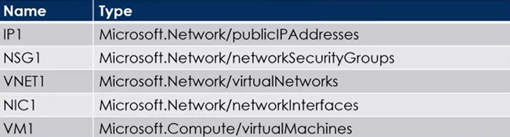

You need to create a single Azure Resource Manager (ARM) template that will be used to deploy the resources. Which resource should be added to the dependsOn section for VM1?

A. VNET1

B. NIC1

C. IP1

D. NSG1

**173.** You have an Azure subscription that contains a storage account named storage1. The storage1 account contains a container named container1. You need to configure access to container1, and the solution must meet the following requirements:

* Only allow read access.
* Allow both HTTP and HTTPS protocols.
* Apply access permissions to all the content in the container.

What should you use?

A. an access policy

B. a shared access signature (SAS)

C. Azure Content Delivery Network (CDN)

D. access keys